**Assignment 1**

1. WITHDRAW_MONEY Use Case Description: Main Flow

|  |  |
| --- | --- |
| User Action | System response |
| 1. User enters **PIN** into main screen | System checks validity of PIN and presents options to user on another screen |
| 1. User selects **Withdraw Money** | System prompt to enter withdrawal amount on the screen |
| 1. User enters withdrawal amount | System checks customer account if sufficient amount is available to be withdrawn and provides the requested amount. |

1. Use Case Diagram for the ATM system

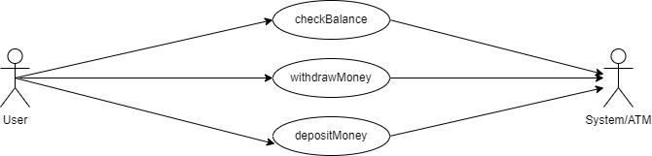

1. Class Diagram for Project Management Tracking System

1. Class Diagram for Properties Management System

